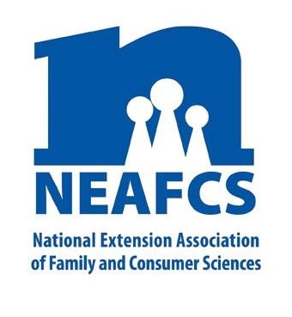
IMPACT 2014

Through Extension programs across the nation, Family and Consumer Science Extension Educators provide a multitude of educational opportunities to meet the needs of diverse audiences.

Childhood Obesity

USDA Secretary Tom Vilsack, along with First Lady Michelle Obama, announced proposed guidelines for local school wellness policies that will further improve the school nutrition environment for children. When peer pressure and stigma drive students to eat less healthy “competitive” foods, instead of healthy school meals, they lose out nutritionally and their families lose financially. While the early childhood obesity rate is down for children ages two to five, it still is rising for other youth. Childhood obesity leads to increased health care costs and a significant decrease in lifespan.

Growing Healthy Foods: Garden-Enhanced Nutrition Education

Grow Healthy New Jersey is a USDA Team Nutrition, garden-based school wellness initiative reaching K-6 students, families, foodservice, and school personnel. It provided foodservice trainings, nutrition education, a pedometer challenge, parent engagement, and assisted with the development of a school wellness council. Funding for this program was renewed and has expanded to child care centers.

NEAFCS National Office | 20423 State Road 7, Suite F6-491 | Boca Raton, FL 33498
(561) 477-8100 | FAX (561) 910-0896 | www.neafcs.org
Caribou, Maine youth successfully planted raised beds with the help of University of Maine Extension Homemakers, local farmers, and Master Gardeners. These volunteers, along with the Parks & Recreation Director, were instrumental in the program’s success which featured learning how to make “rainbow kale smoothies.”

Nutrition Education
Just Be It! Healthy and Fit is an elementary-age childhood obesity prevention program. Over 650 New Mexico youth participated in field trips, workshops, and classroom instruction, with up to 46% reporting increased knowledge of nutrition, physical activity, food labels, and food choices.

Strengths of the Tatanka’s Healthy Tales curriculum are its tie to South Dakota Native American culture, its study population of nearly 500 students, and its promotion of physical activity, low-fat dairy products, fruits, and vegetables.
“He reminds us we need to exercise as a family.” --Parents of a North Dakota fifth grader

Oklahoma’s OrganWise Guys (OWG) program generated 107,800 contacts through radio PSAs, 1,485 contacts through TV PSAs, 16,540 contacts through educational articles, and 1,490 contacts through community events & an online OWG website. Over 1,380 youth reported eating increased servings of fruit, vegetables and skim milk, and being more physically active.

Growing Strong Bodies and Minds aims to promote the development of healthful food preferences, physically active lifestyles and literacy skills in young children.
Specific goals include: using pre-reading and reading
strategies to teach nutrition; promoting the consumption of whole grains, fruits, vegetables and low-fat dairy foods, and increasing active play time. More than 3,335 Oklahoma youth participated in this program with students discussing the foods they eat during lunch and talking to their families about the new foods they try.
School Nutrition Programs - USDA Standards

Shelby County, Kentucky conducted Healthy Eating - Healthy You with 750 fourth and fifth graders. As a result, 92% now eat breakfast, 76% choose healthier snacks, and 60% eat five or more fruits and vegetables every day. As a result of attending Delaware’s Obese Kids: They Are What They Eat, childcare providers reported they gained greater knowledge about label reading, portion sizes, and sugar in juices.

Body Quest: Food of the Warrior, a childhood obesity prevention 17-week long program, was successful in increasing fruit and vegetable consumption as measured through foods eaten in the school lunch program by third graders, especially when it came to vegetable intake. Over 2,560 students benefited from this program which was funded by the Alabama Cooperative Extension System and USDA’s SNAP-Ed.
In Tennessee, Power U helped fourth and fifth graders in 178 classrooms in 50 different schools in 20 counties make better decisions about food and physical activity while learning skills needed for successful careers. Students were exposed to new fruits and vegetables through tasting experiences. Of the 375 individuals

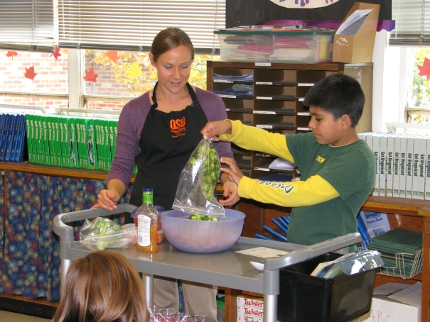

enrolled in Texas Cooking Well with Diabetes, 85%
learned how to recognize starchy vegetables, and 97% knew which cooking method would not reduce the fat content of the food.
In West Virginia, “Choose to Change” -- a two-county, multi-year grant-funded project – is underway and will include a strong research component consisting of focus groups, in-home data collection, environmental surveys, preschool classroom instruction, and family fun evening events.

In Minnesota the Extension office is countering Childhood Obesity, and Food, Nutrition, and Health by offering trainings to school foodservice teams about health eating initiatives, and increasing consumptions of fruits and vegetables. “Energizers” are also being offered in classrooms to pair physical activity with academic concepts.
Increasing Physical Activity
Because of FCS Extension programs in Kentucky, 30,460 people reported being more physically active, resulting in healthier families and helping stem the tide of childhood obesity.

In North Dakota, On the Move to Better Health is a five-week curriculum for fifth graders. Post-surveys of 2,100 children showed that 62% drank less soda pop, 59% chose more healthful snacks, and 58% increased their daily amount of physical activity.
Healthy Steps, a nutrition and physical activity program for preschoolers was implemented in 18 Tennessee counties. Over 3,000 direct contacts were made in voluntary Pre-K, Head Start and center-based classrooms; 72,871 indirect contacts were made through exhibits, newspaper articles, publications, and television.

This report was compiled by Karen Ensle, Rutgers Cooperative Extension, Public Affairs Advocacy Subcommittee member, and Theresa Mayhew, Cornell Cooperative Extension, Vice President – Public Affairs. For more information, email tcm5@cornell.edu.

